Recognized pattern:

Gumen_variety1

The form of the pattern:

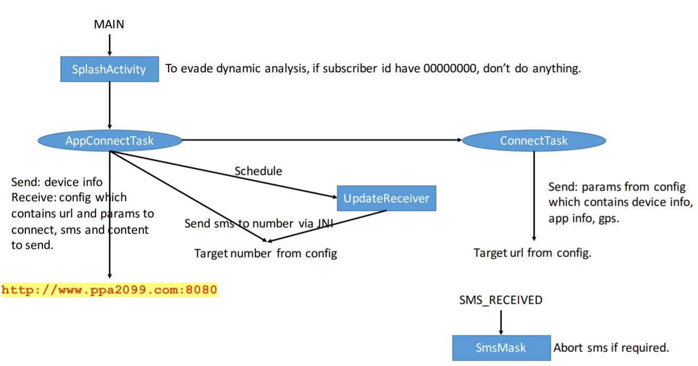

Name of Sample app:

Cyclists

The name of this app:

Catapult

There is no matching code between this app and sample app